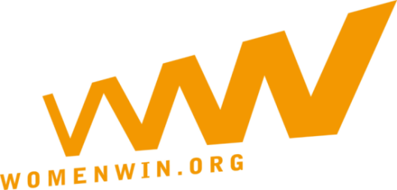
Community Event Report
1. Who organizes and leads this event? Please provide name of primary leader(s) and specify how many people have been supporting the organization.

2. What are the objectives and goals? Please be specific and if more objectives, please describe how/ if they relate to each other.

3.What is the target group (girls, teachers, parents, community leaders etc.) and who are the direct beneficiaries of this event?

4.Who are the indirect beneficiaries of this event? (Who will be watching/ supporting/ get informed about the event)

5. Short description of the activities and overall project and workplan, as well as location (s), duration and setting.

6. How many people (of the direct and –if possible – indirect beneficiaries) have been reached?

7. What is the result and outcome of the event? Please try to report in short and long term results, and explain if you have achieved your pre-set goals.

8. Can you please provide us the lessons you learned around the planning and delivery of the event? Are there things or you would do differently for a next event?

